Table created - 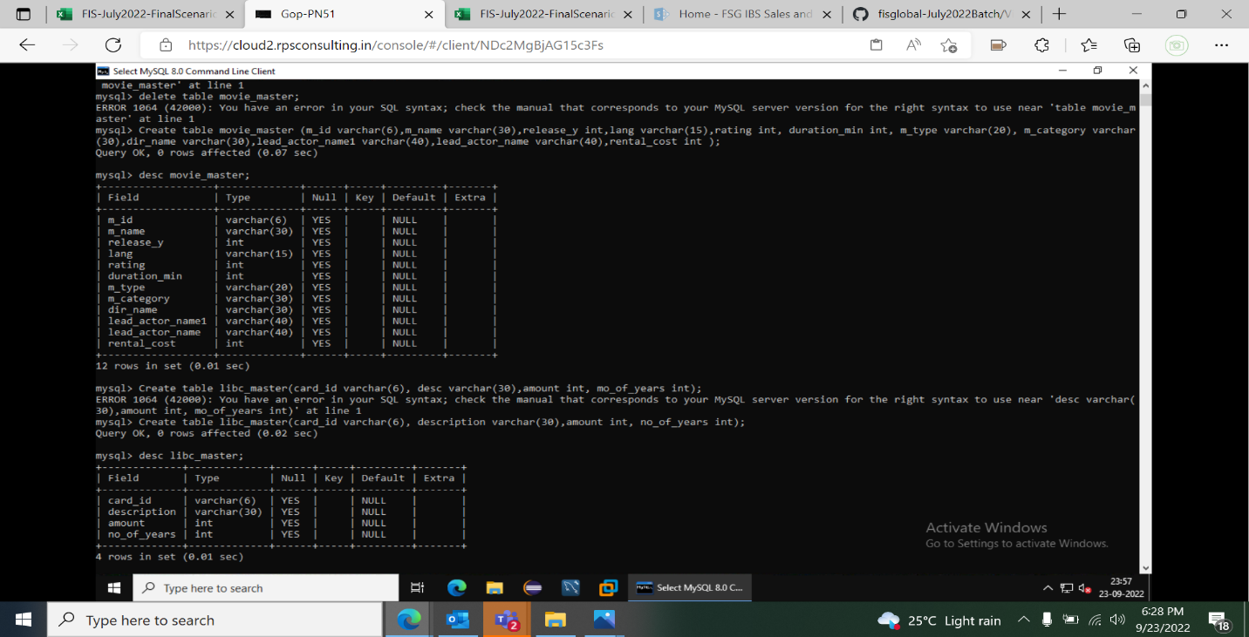

Primary and foreign key-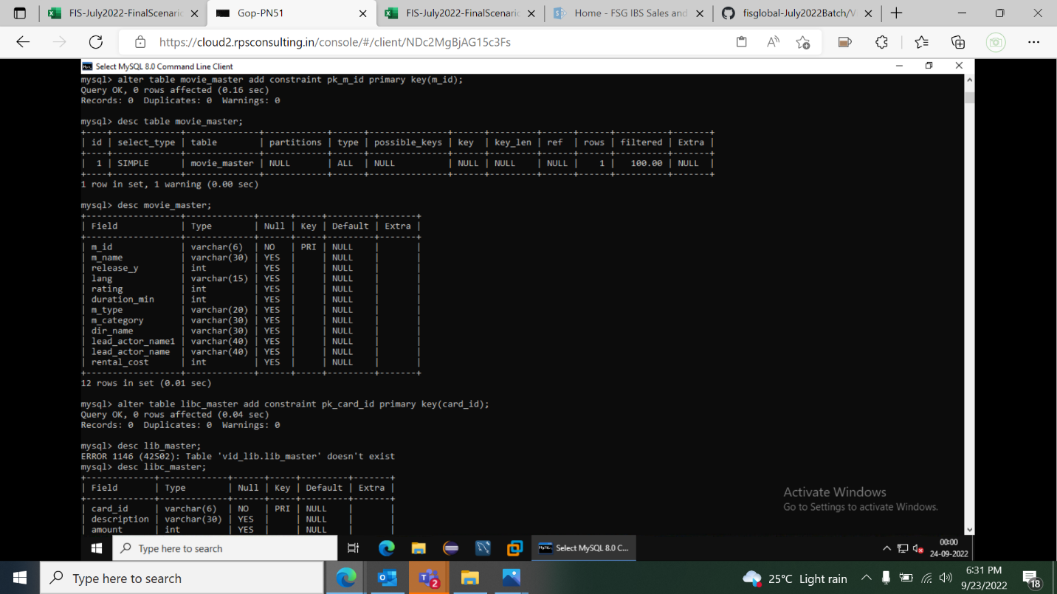

Inserting data –

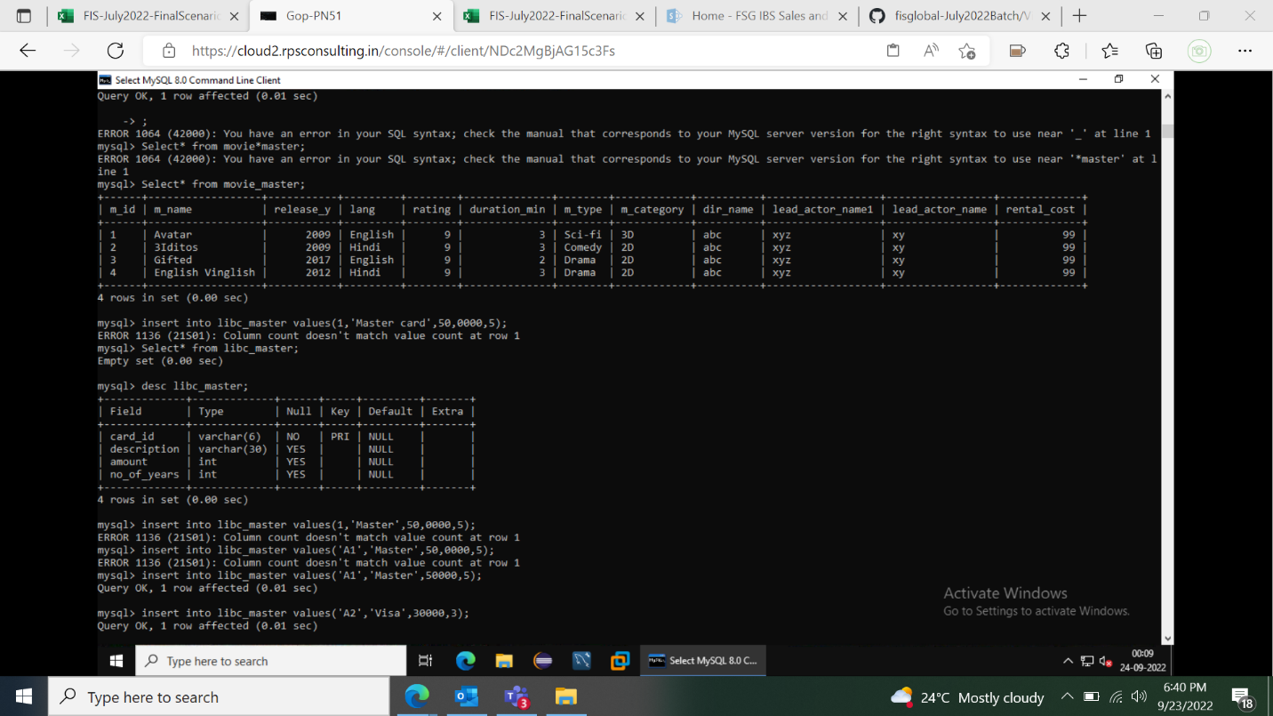

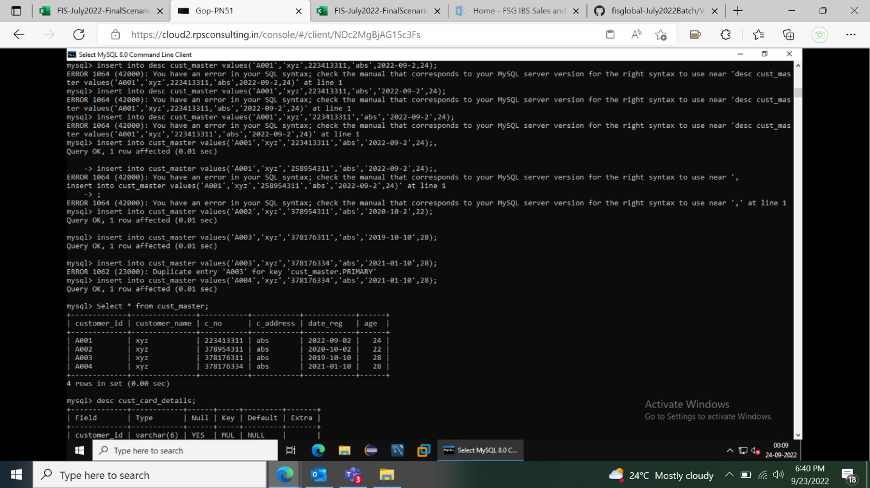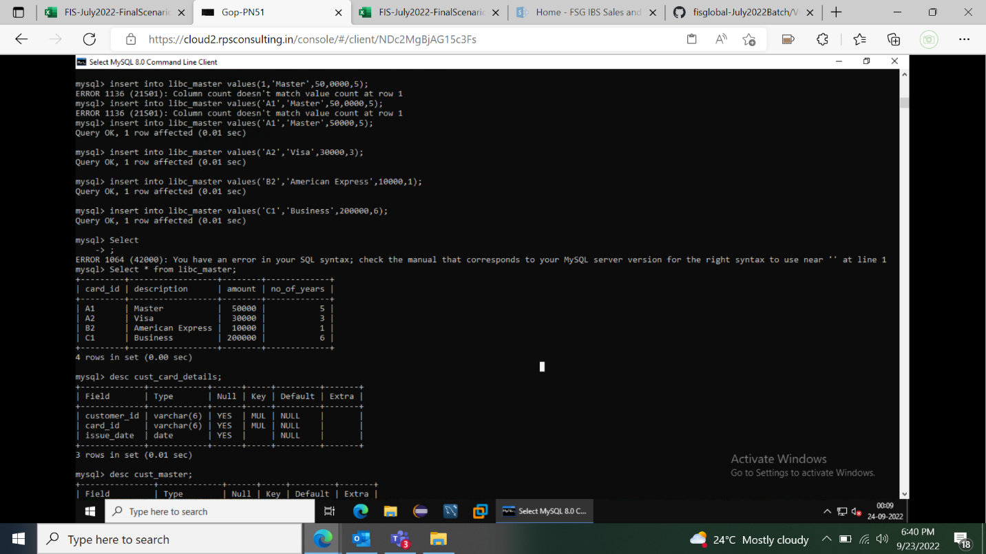

Queries -

|  |
| --- |
| 1.Write a query to display movie names and number of times that movie is issued to |
| customers. Incase movies are never issued to customers display number of times as 0. Display |
| the details in sorted order based on number of times (in descending order) and then by |
| movie name (in ascending order). The Alias name for the number of movies issued is |
| ISSUE_COUNT.   |
|  |
|  |
| 2.Write a query to display id,name,age,contact no of customers whose age is greater than 25 |
| and and who have registered in the year 2012. Display contact no in the below format +91- |
| XXX-XXX-XXXX example +91-987-678-3434 and use the alias name as "CONTACT_ISD". If the |
| contact no is null then display as 'N/A' Sort all the records in ascending order based on age |
| and then by name. |
|  |
| 3.Write a query to display the movie category and number of movies in that category. Display |
| records based on number of movies from higher to lower order and then by movie category |
| in ascending order.Hint: Use NO_OF_MOVIES as alias name for number of movies. |
|  |
|  |
| 4.Write a query to display the customer id, customer name, year of registration,library card |
| id, card issue date of all the customers who hold library card. Display the records sorted by |
| customer name in descending order. Use REGISTERED_YEAR as alias name for year of |
| registration. |
|  |
|  |
| 5. .Write a query to display issue id, customer id, customer name for the customers who have |
| paid fine and whose name starts with 'R'. Fine is calculated based on return date and actual |
| date of return. If the date of actual return is after date of return then fine need to be paid by |
| the customer order by customer name. |
|  |
|  |
| 6. Write a query to display the customer id, customer name,contact number and address of |
| customers who have taken movies from library without library card and whose address ends |
| with 'Nagar'. Display customer name in upper case. Hint: Use CUSTOMER_NAME as alias |
| name for customer name. Display the details sorted in ascending order based on customer |
| name. |
|  |
| 7. Write a query to display the movie id, movie name,release year,director name of movies |
| acted by the leadactor1 who acted maximum number of movies .Display the records sorted in |
| ascending order based on movie name. |
|  |
|  |
| 8. Write a query to display the issue id,issue date, customer id, customer name and contact |
| number for videos that are issued in the year 2013.Display the records in decending order |
| based on issue date of the video. |
|  |
|  |
| 9. .Write a query to display number of customers who have registered in the library in the |
| year 2012 and who have given/provided contact number. <br> Hint:Use NO_OF_CUSTOMERS |
| as alias name for number of customers.   |
|  |
| 10. Write a query to display the customer id , customer name and number of times movies |
| have been issued from Comedy category. Display only for customers who has taken more |
| than once. Hint: Use NO_OF_TIMES as alias name Display the records in ascending order |
| based on customer name.   |